Monday 1st March Maths Challenge
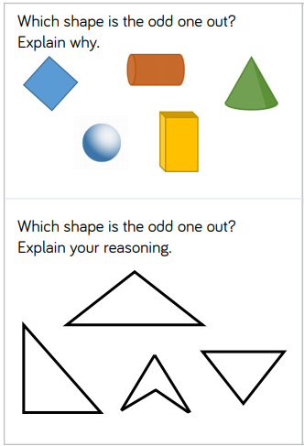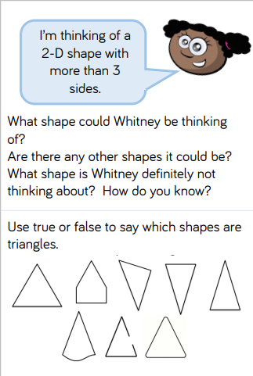

Monday 1st March English Challenge
A challenge for this task would be to list expanded noun phrases to describe your character and setting. Can you research your animal and make sure that your setting is correct? Find out more information about the animal and its habitat to add more detail and use specific vocabulary about your animal and where it lives. List these to use in your writing later in the week.

Tuesday 2nd March Maths Challenge
Tuesday 2nd March English Challenge
For a greater challenge with this activity use a range of conjunctions not just “and”.
Find out about your settings and use expanded noun phrases to add detail. Change these settings as well and think carefully about what might happen at each location making sure it fits.
e.g – There wouldn’t be a flood in a desert.

Wednesday 3rd March Maths Challenge

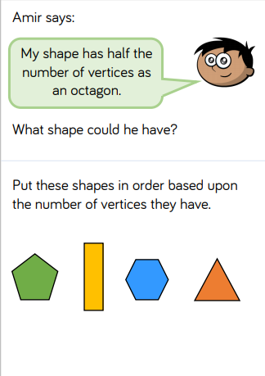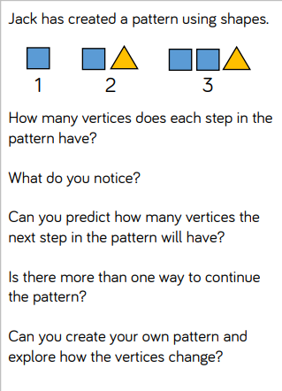

Wednesday 3rd March English Challenge
For a greater challenge with this activity use this checklist:
Don’t forget to include:
• expanded noun phrases (using words with suffix -est and -er)
• precise verb choices (instead of using the verb “went”, can you use improved verbs such as “travelled”, “scurried”, “ran”, “walked”, “set off”, “marched” etc.)
• a simile
• alliteration
• sentence openers

Friday 5th March Maths Challenge
