Maths Assessment wc 08.02.21 Name………………………………………………………………………………………………………………………………………….

5. Circle the shortest tower. Circle the tallest tower.

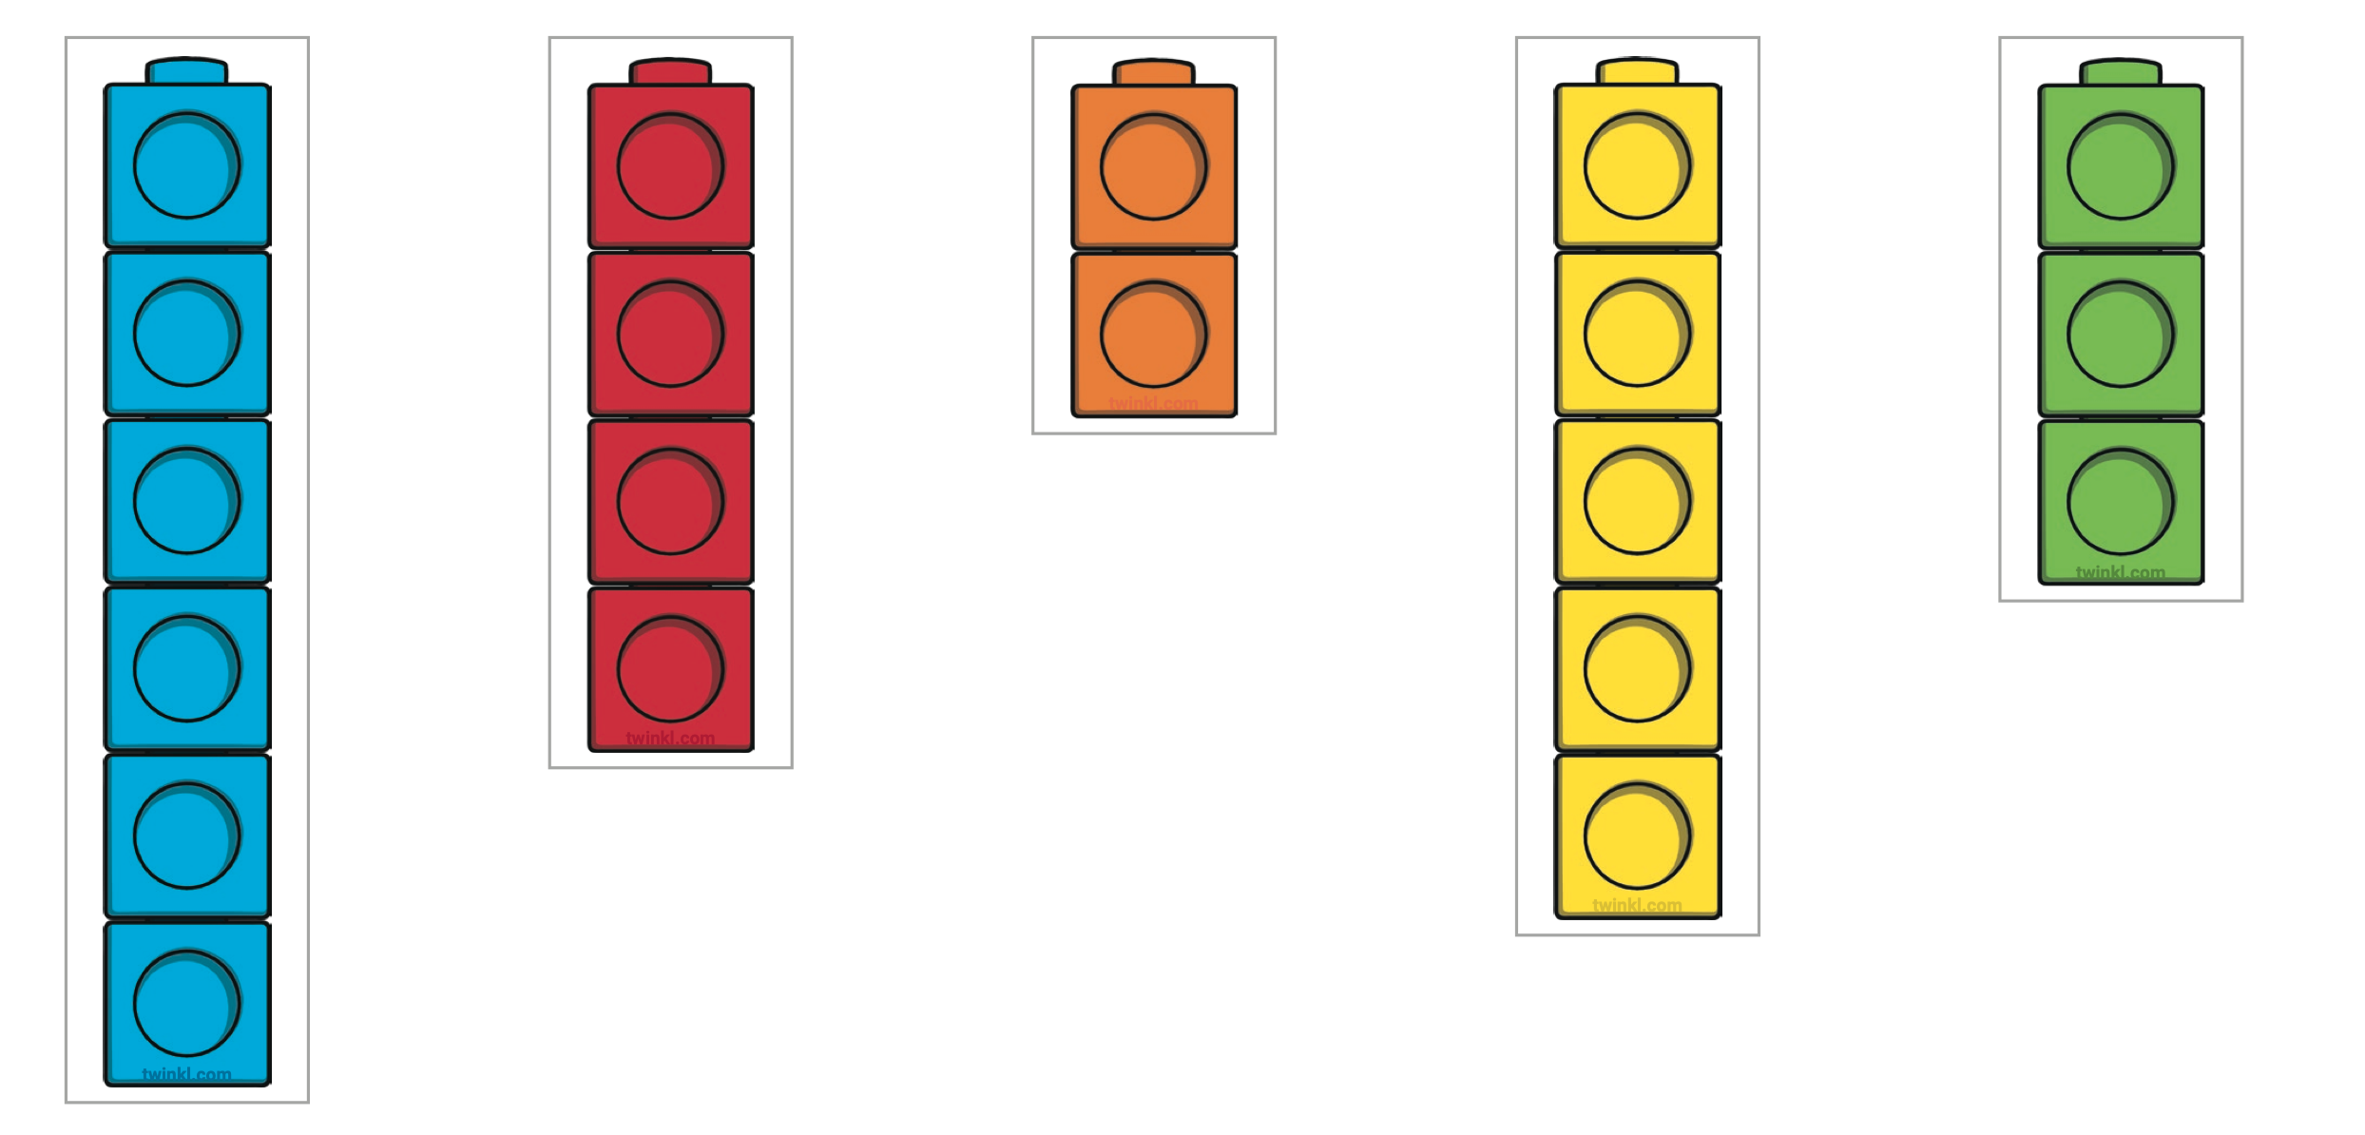

6. Tick the longest caterpillar.
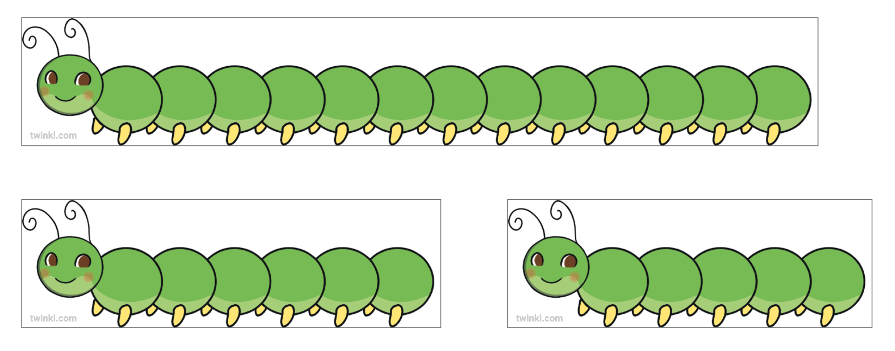

7. Circle the ladybirds which show 8.
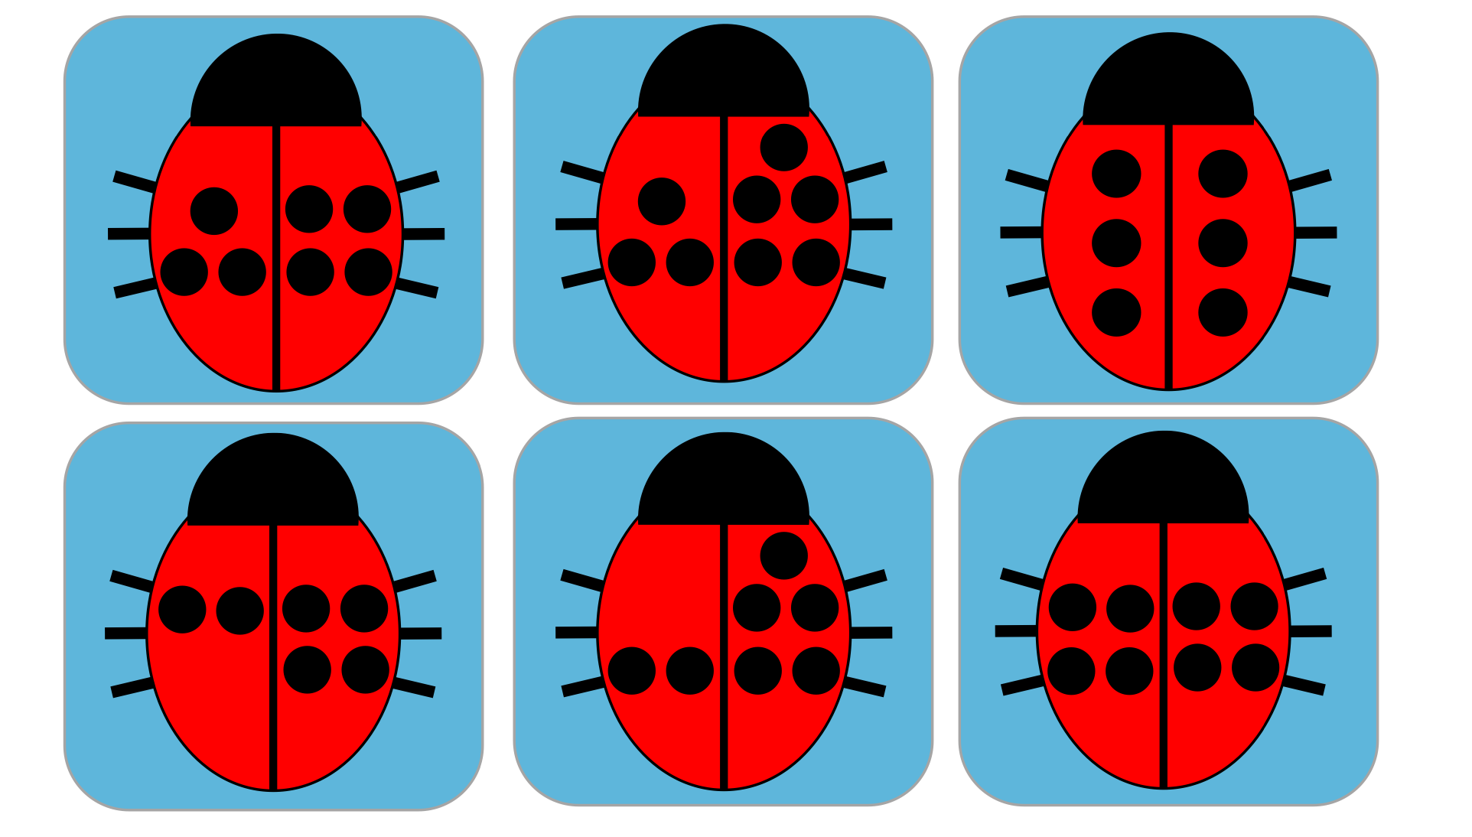

8. Looking at the picture, can you write a calculation about what it shows.

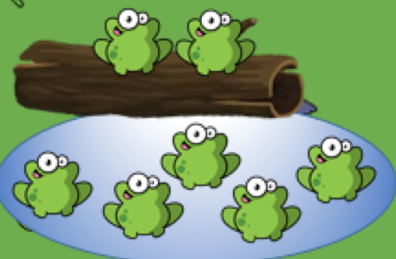……………………………………………………………………
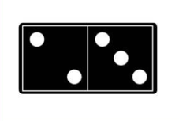
- Circle the pictures that show 5.
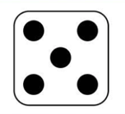

- Circle the container which is half full.
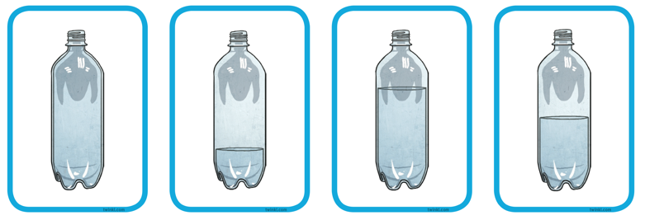

- Circle the heaviest item and explain how you know.
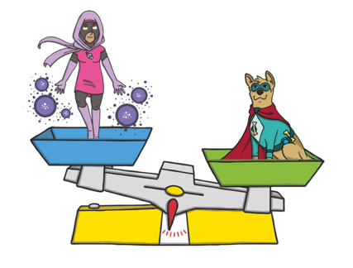

*adults to write down child’s reasoning.
………………………………………………………………………………..
………………………………………………………………………………..
………………………………………………………………………………..
4. Form the numbers 0-8 on below.

……………………………………………………………………………………………………………………

