Year 2 Home Learning
1st – 2nd July 2021
 | Morning |  |  |  |  |  |  |  | Afternoon
 | PHONICS | READING | ENGLISH |  | MATHS | HANDWRITING | SPELLINGS |  | TOPIC | READING
Mon |  | Daily Oxford Owl eBook  https://www.oxfordowl.co.uk/  Username: class1gis  Password: 12345 |  | Break  Playtime |  |  | should  would  could  sure | Lunch |  | Daily Reading for Pleasure Time - Choose a book to read from your home collection to share or read independently.
Tues
Wed
Thurs | Suffixes  Teach writing the word ‘could’.  Recap the suffixes the children have learnt in Year 2. Recap the rules: do nothing, double the consonant and add the suffix, drop the e and add the suffix and change the y to i and add the suffix. Read the words with the suffixes. Identify the suffix in each word:  putting, buried, paler, hottest What rule has each word used? Write the words and add the suffix:  fake -ing  hop -ed  furry -er  crazy – est  Which rule do we need to follow for each word?  Choose a word and write a sentence. Can you add an expanded noun phrase and a conjunction? |  | Persuasion  Box up the persuasive text “Wanted Dragon Catcher” into three parts – Introduction, Making your point and Conclusion.  Use pictures and key words to help you remember the text.  N.B. The children have already started to learn this in class this week with actions they have made up. |  | Four Operations with length  Watch the video:  https://vimeo.com/531648374  Complete the worksheet:  https://resources.whiterosemaths.com/wp-content/uploads/2020/01/Y2-Spring-Block-5-WO5-Four-operations-with-lengths-2019.pdf | Practise joins to the letter s:  es  as  is  us |  |  | Design and Technology  Sensational Salads  Read the instructions for making a potato salad and follow them.  Evaluate your salad. What did you find tricky? What did it taste like? What did it look like? How many starts out of 5 would you give it?
Fri | Suffixes  Teach writing the word ‘sure’.  Recap the suffixes the children have learnt in Year 2. Recap the rules: do nothing, double the consonant and add the suffix, drop the e and add the suffix and change the y to i and add the suffix.  Read the words with the suffixes. Identify the suffix in each word:  coming, dried, wiser, prettiest  What rule has each word used?  Write the words and add the suffix:  slide -ing  knit -ed  rude -er  early – est  Which rule do we need to follow for each word?  Choose a word and write a sentence. Can you add an expanded noun phrase and a conjunction? |  | Persuasion  Write the Making your point part of the text using the box up pictures and key words.  Please allow your child to write this section without copying the words from the text. |  | Problem Solving with Length  Watch the video:  https://vimeo.com/531648411  Complete the worksheet:  https://resources.whiterosemaths.com/wp-content/uploads/2021/02/Y2-Spring-Block-5-WO-Problem-solving-with-length-2020.pdf | Practise writing the words with es join:  was  his  plus  dishes |  |  | Science  Living Things and their Habitats  Research a world habitat e.g. the rainforest, The Arctic or the desert. Find out about the following things for your chosen habitat.  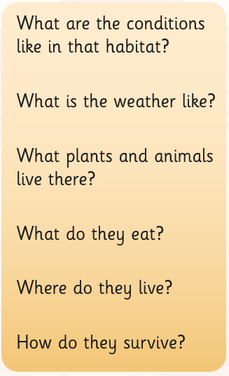  Write a report using the questions as sub-headings.

Please send any completed work to our school email address: gis.year2@schools.sunderland.gov.uk

